1、Install Rockchip poduction tools，reference the installation manual《瑞芯微量产工具使用说明.doc》

2、Tools installation is completed.enter the tools directory,click on RKBatchTool.exe to open the tools

3、Open the tool as follows，select the Language Settings(Chiness or English)

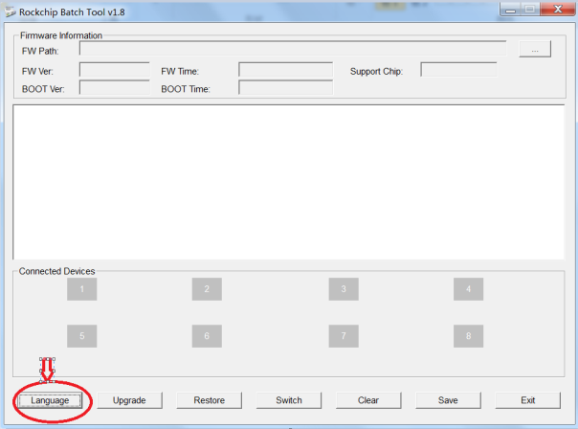

4、Import the upgrade firmware

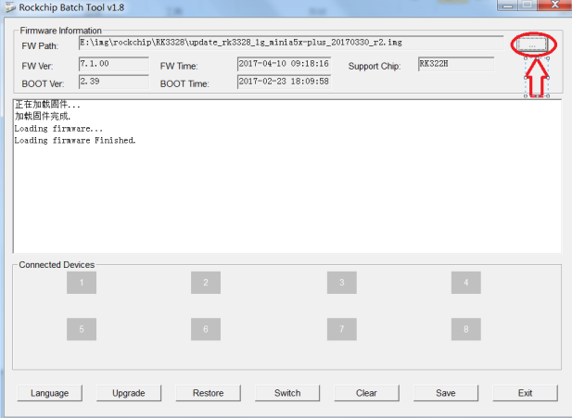

5、Connect PC to the devices with USB cable

Hold the button of inside the AV interface， then connected to the USB port of device with USB cable.

a.

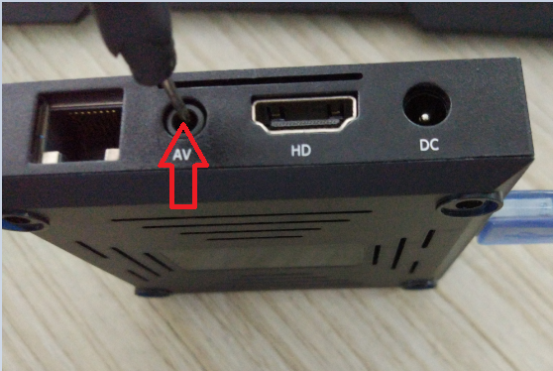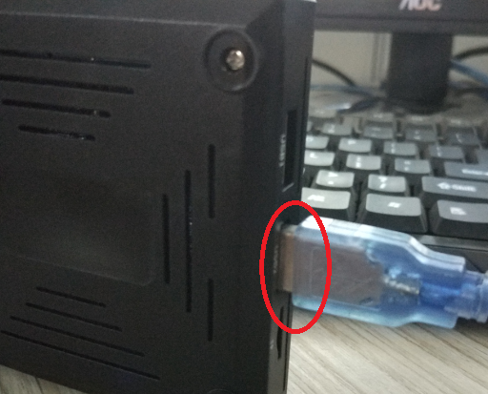

b.

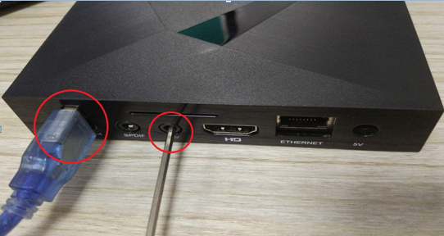

c. (micro usb)

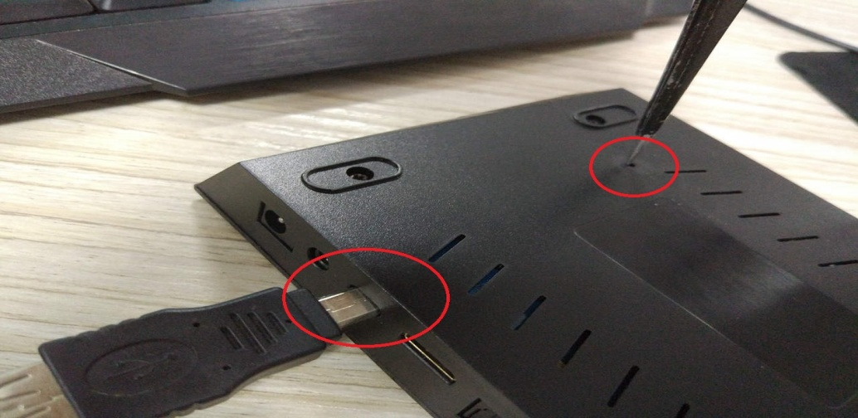

Successful connection

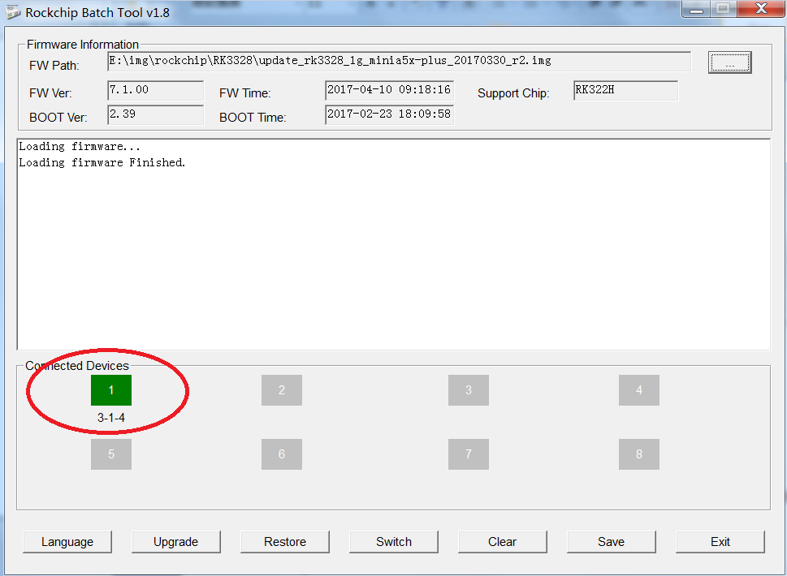

6、Click on Upgrade to start Upgrade

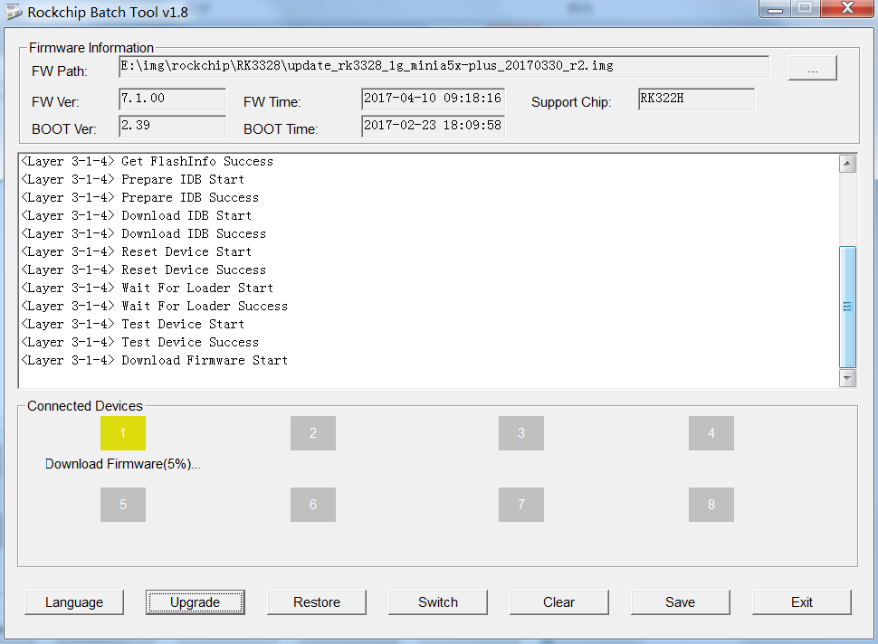

Don't interrupt ,wait for it upgrade done success

